Thank you for your interest in our current vacancy of Community Development and Volunteer Coordinator.

Please find enclosed or attached the Job Description, Person Specification and Application pack. We do not accept CVs in place of a completed application form.

The closing date for receipt of completed applications is Monday 2nd February 2026 at 9am..

The interviews will take place the following week.

Please return the completed form by email to: David.Kay@northmoorcommunity.org

Kind regards

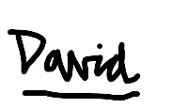

David Kay
Interim Centre Manager (Maternity Cover)
Northmoor Community Association
0161 248 6823
David.Kay@northmoorcommunity.org

